Copyright and Fair Use

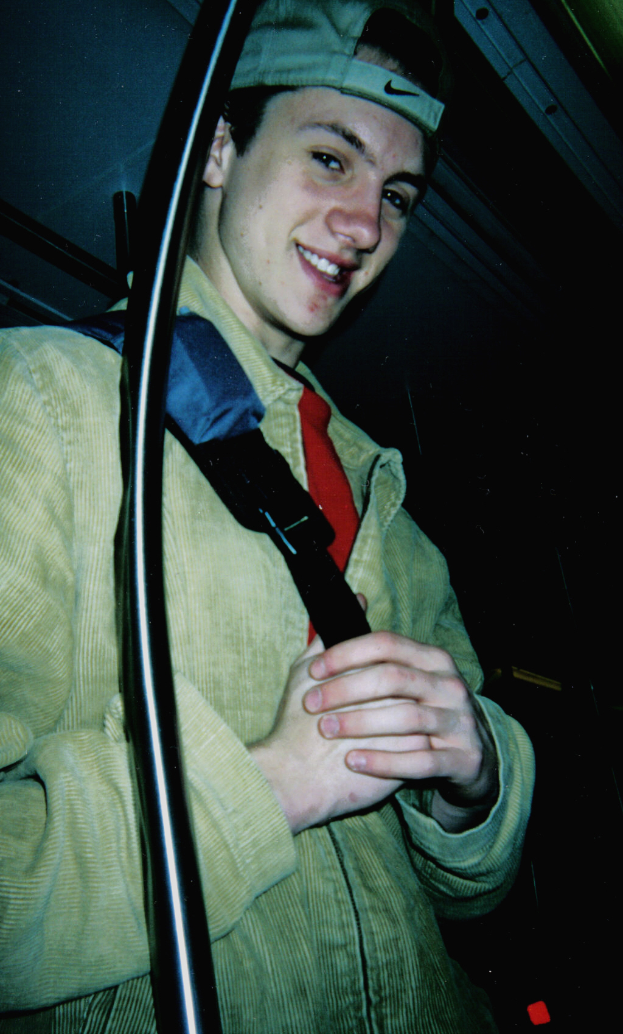

Copyright
What is Copyright? Copyright is a protection that covers published and unpublished literary, scientific and artistic works, whatever the form of expression, provided such works are fixed in a tangible or material form. This means that if something is copyrighted special permission must be given to the user by the author in order for a person to be able to use that work.

Fair Use
Fair use is a little more tricky than copyright laws. Fair use or fair practice is using of a portion of a copyrighted work "as is" for purposes of parody, news reporting, research and education about such copyrighted work without the permission of the author. Fair use allows people to use materials without the consent of the author for specific uses. Even with fair use there are limitations on how much one can use of a resource.

